**Applied Distributed System**

**COIT132229**

Student Name : Md Afsar Uddin Salman

Student Id : 12190848

**Table of Contents**

1.0 Usage Guide 1

1.1 Prerequisites 1

1.2 Building and Running the Application 1

2.0 Ports Used: 2

3.0 TCP Application Testing Screenshots 2

4.0 Valid Inputs: 2

5.0 Invalid Inputs: 4

# Usage Guide

In this section, we will see the instructions on how to build and run the **OnlineStore** program while working with multiple servers using TCP connections.

## Prerequisites

Before building and running the client-server application for the fitness club, ensure that you have the following prerequisites installed and configured:

* **Java Development Kit (JDK):** Ensure that you have JDK installed on your system. The application is written in Java and requires JDK to compile and run.
* **Access to the** [**OnlineStoreJavaTCP**](https://github.com/idg-salman/OnlineStoreJavaTCP.git) **Repository:** You will need to have access to the [**OnlineStoreJavaTCP**](https://github.com/idg-salman/OnlineStoreJavaTCP.git)repository containing the client-server application source code.

## Building and Running the Application

Follow these steps to build and run the client-server application:

* Download the [**OnlineStoreJavaTCP**](https://github.com/idg-salman/OnlineStoreJavaTCP.git) repository from GitHub to your local machine.
* Extract the downloaded file to the folder of your choice.

The application has two parts; register member part and manager part – where each part is a complete client/server application.

To execute the register member part, follow these steps:

* Open the command prompt or Apache NetBeans IDE.
* Navigate to the directory containing the [**OnlineStoreJavaTCP**](https://github.com/idg-salman/OnlineStoreJavaTCP.git)files.
* Compile and run the following files in any order:

|  |  |  |
| --- | --- | --- |
| javac ServerCoordinator.java  java ServerCoordinator | javac ServerBook.java  java ServerBook | javac ServerMovie.java  java ServerMovie |

* Compile and run the OrderClient file.

javac OrderClient.java

java OrderClient

* Now provide valid and invalid inputs to test the application.

# Ports Used:

|  |  |  |
| --- | --- | --- |
| ServerCoordinator | Server | 4808 (ServerSocket) |
| ServerBook | Server | 4806 (ServerSocket) |
| ServerMovie | Server | 4804 (ServerSocket) |
| OrderClient | Client | 4804 (Socket) |

# TCP Application Testing Screenshots

## Valid Inputs:

OrderClient Outputs:

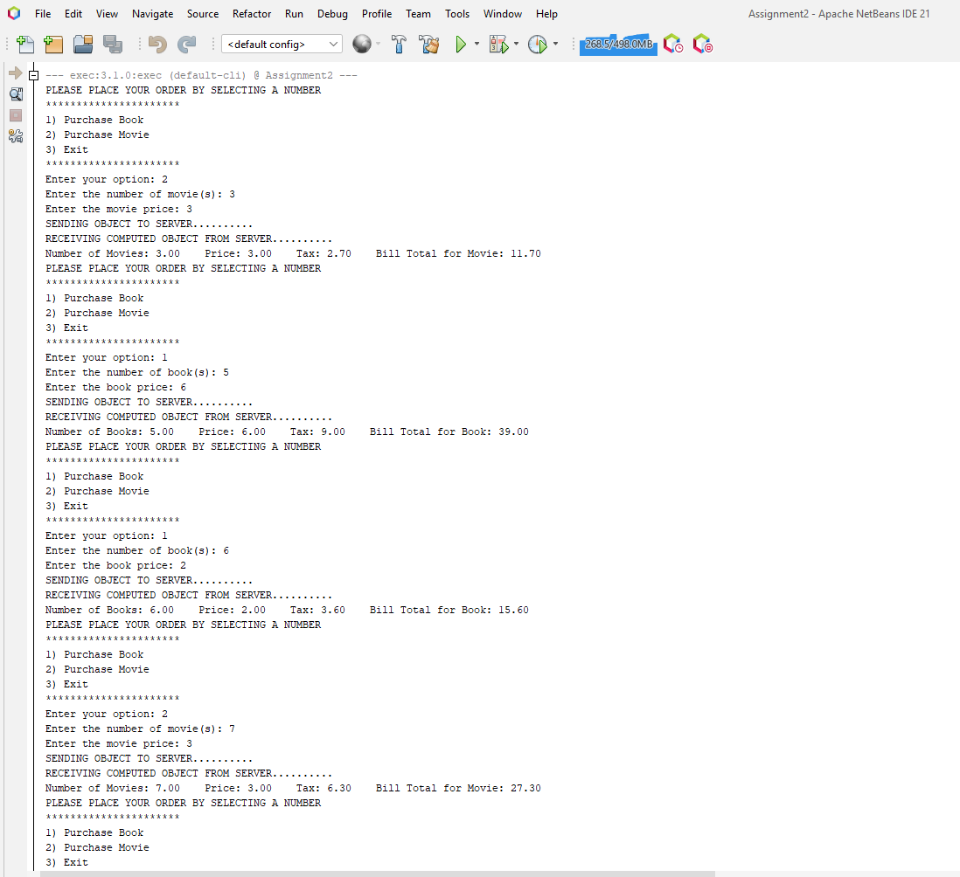

ServerMovie Outputs:

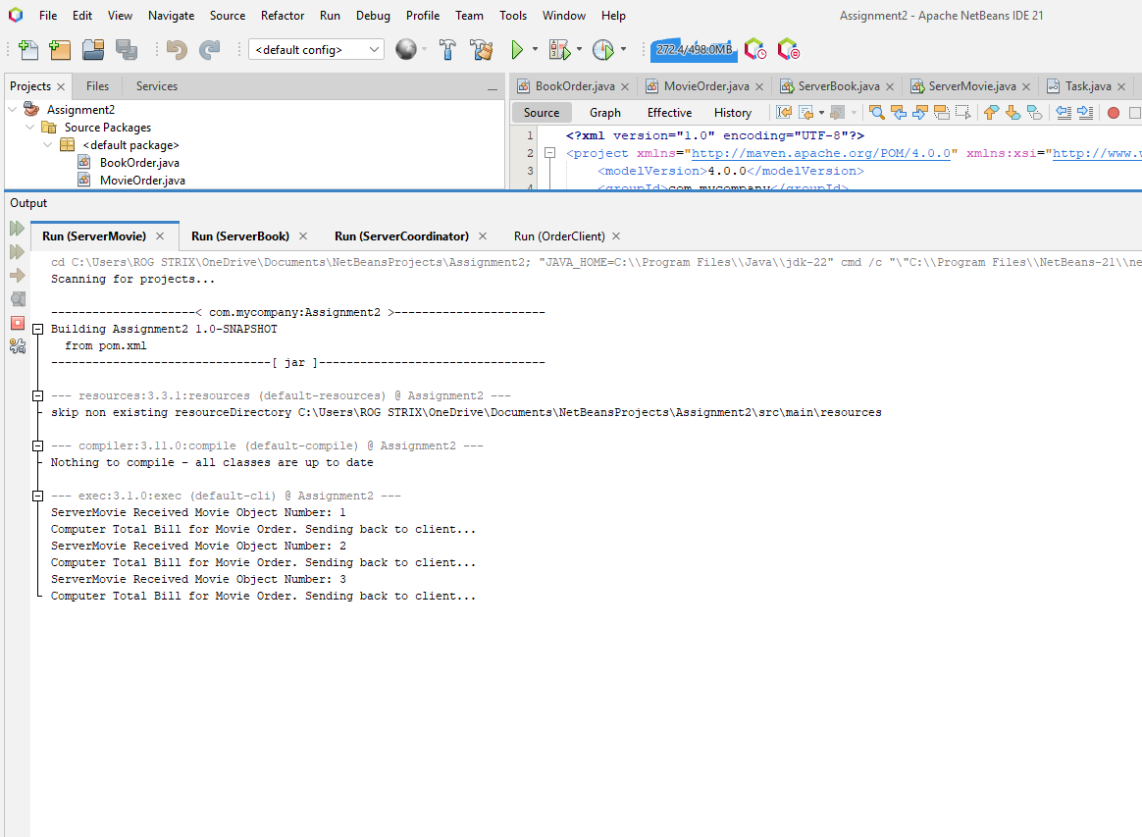

ServerBook Outputs:

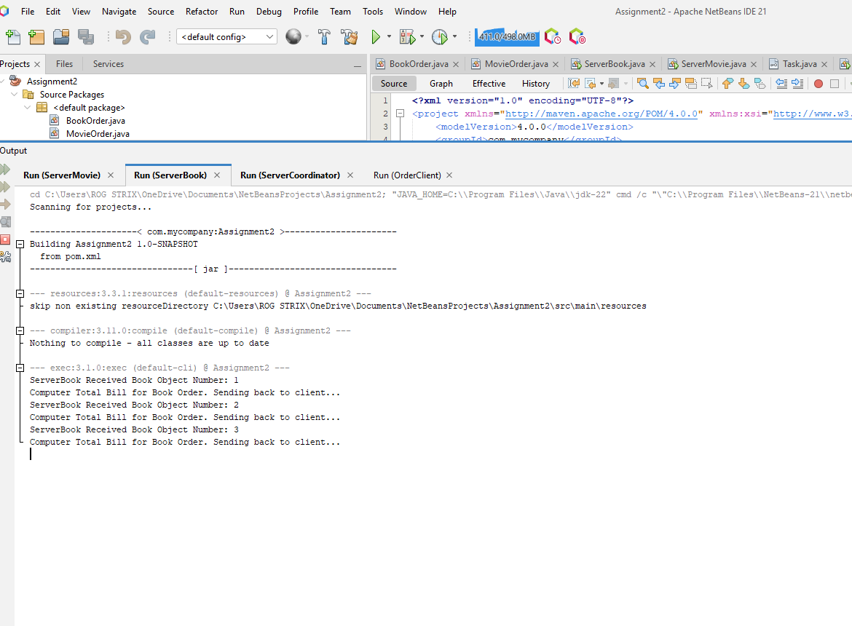

ServerCoordinator Outputs:

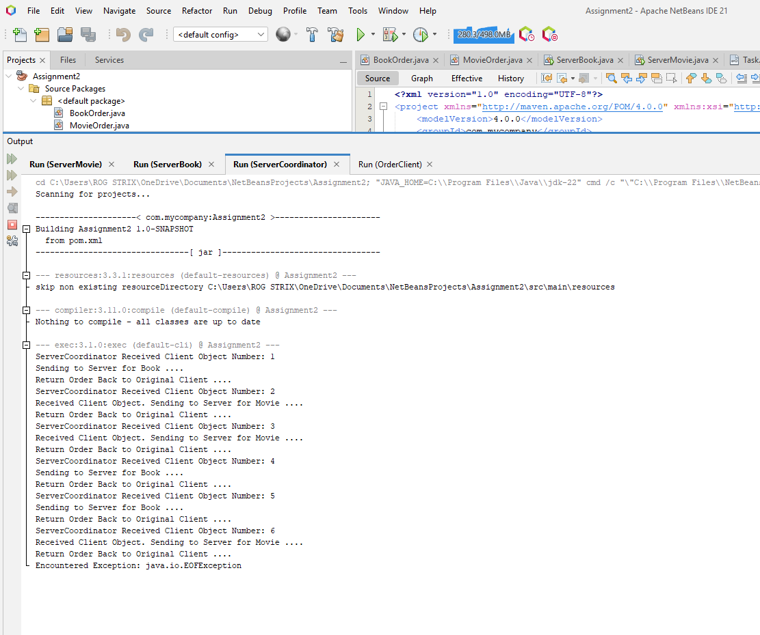

## Invalid Inputs:

Invalid inputs are checked in case of:

1. Invalid option pic (outside of 1, 2 and 3)
2. Invalid amount pick (less than zero)
3. Invalid price picked (less than zero)

In every case the user is stuck into a loop until they enter a valid value.

